SPRINT-3

|  |  |
| --- | --- |
| Date | 09 November 2022 |
| TEAM ID | PNT2022TMID26051 |
| Project Name | Smart Crop Protection System for Agriculture |
| Maximum mark | 20 marks |

STEP1: Simulated program to get the random values.

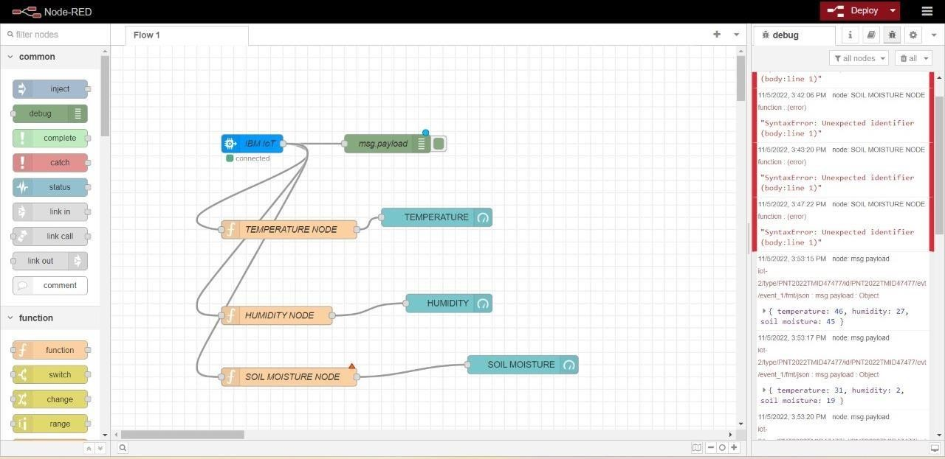

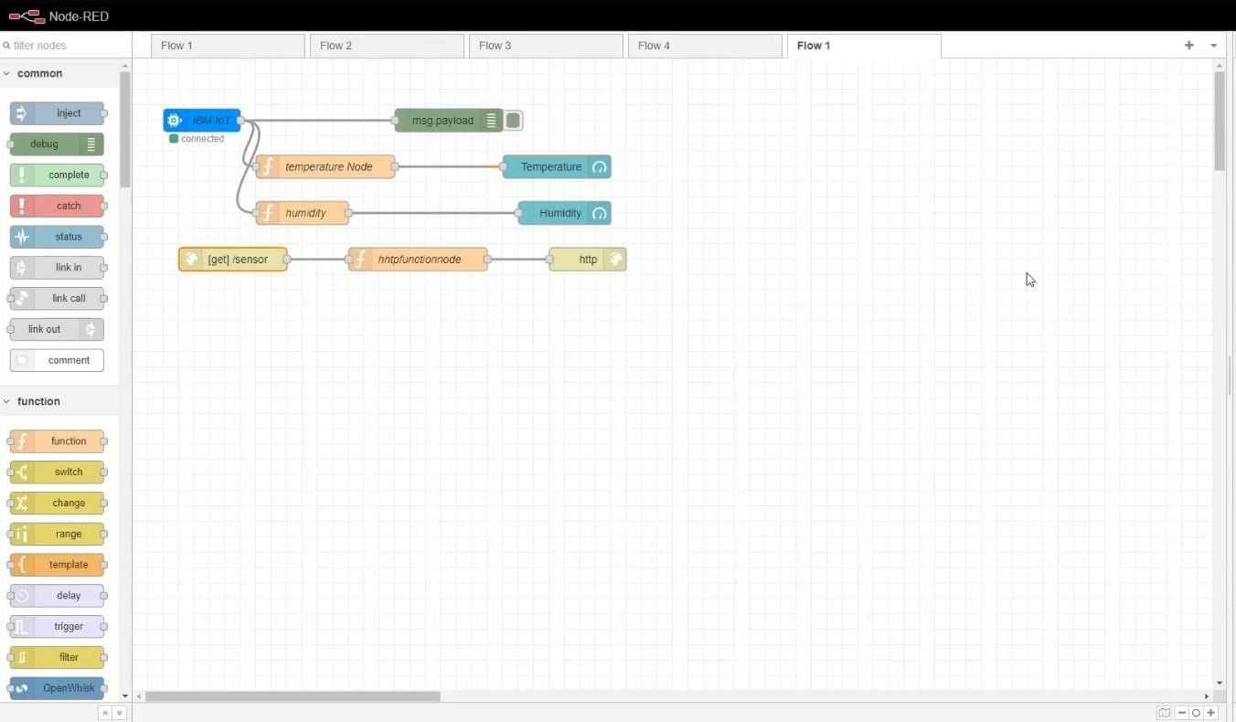

STEP2: Generate debug message from IBM Watson IoT Platform and connect the nodes.

STEP3: Generate the some output from recent events.

